SBIT TRAINING ACADEMY

SUBMITTED TO MR.KARTHI GEYAN
IN PARTIAL FULFILLMENT
OF THE REQUIREMENTS FOR THE COURSE

ML421
Machine Learning Program in Python
IN CANDIDACY FOR THE
DEGREE IN SOFTWARE ENGINEERING
BY
Tan Jia Yong
28/7/2025

Contents
Introduction 1
Project Background 1
Proposed System and Objectives 1
Design Outline 2
Machine Learning Program Design Outline 2
Output 4
Machine Learning Program Design Output 4
Development Coding 6
Coding 6
Testing 7
User Guide 8
Conclusion 9
References 10

Introduction

Fruit prices are an important part of daily life because they affect both consumers and sellers in the market, and prices can vary depending on the type of fruit, its form (fresh, canned, or frozen), and other factors such as yield and equivalent cup size. In this project, I use a real dataset of fruit prices to apply basic machine learning methods. The dataset includes information such as fruit name, form, retail price, yield, and equivalent cup price. The aim is to explore the data, understand which factors influence fruit prices, and build a simple predictive model.

Project Background

Fruits are part of daily life and their prices are important for both consumers and sellers. The price of fruits can change because of different reasons such as the type of fruit, how it is sold like fresh, canned, or frozen, and the amount that can be eaten after preparation. For buyers, the price affects daily shopping and food choices, and for sellers it affects business and profit. By studying fruit price data, we can see what factors make the price higher or lower, and we can also use simple machine learning to make predictions about fruit prices.

Proposed System and Objectives

The proposed system uses a dataset of fruit prices that includes details such as fruit type, form, retail price, yield, and equivalent cup price. The system applies basic machine learning methods, such as multiple linear regression, to analyze the data and predict fruit prices. The objective of this project is to study how different factors affect fruit prices, to build a simple prediction model, and to show how machine learning can be applied to real-world problems in daily life.

Design Outline
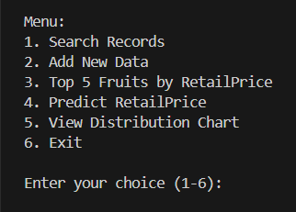

Output (Example)
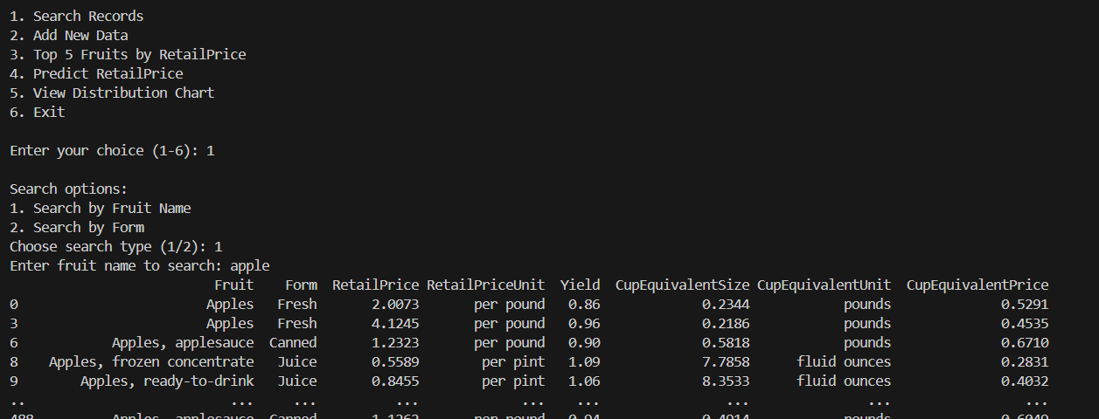

Development Coding
import pandas as pd
import matplotlib.pyplot as plt
import seaborn as sns
import matplotlib
matplotlib.use("TkAgg")
from sklearn.linear_model import LinearRegression
# from sklearn.model_selection import train_test_split

prices = pd.read_csv("fruit_prices.csv")

# pd.set_option('display.max_columns', None)
# pd.set_option('display.max_rows', None)
# pd.set_option('display.max_colwidth', None)

# print("Columns:", prices.columns.tolist())

def search_data():
print("Search options:")
print("1. Search by Fruit Name")
print("2. Search by Form")
choice = input("Choose search type (1/2): ")
if choice == "1":
name = input("Enter fruit name to search: ").strip().lower()
result = prices[prices['Fruit'].str.lower().str.contains(name, na=False)]

elif choice == "2":
form = input("Enter form to search: ").strip().lower()
result = prices[prices['Form'].str.lower().str.contains(form, na=False)]
else:
print("Invalid choice.")
return
if result.empty:
print("No records found.")
else:
print(result)

def add_new_data():
print("Add new record:")
fruit = input("Fruit: ").strip()
form = input("Form: ").strip()
try:
retail_price = float(input("RetailPrice: "))
retail_price_unit = input("RetailPriceUnit:")
yield_ = float(input("Yield: "))
cup_eq_size = float(input("CupEquivalentSize: "))
cup_eq_unit = (input("CupEquivalentUnit:"))
cup_eq_price = float(input("CupEquivalentPrice: "))
except ValueError:
print("Invalid input.")
return

new_row = {
'Fruit': fruit,
'Form': form,
'RetailPrice': retail_price,
'RetailPriceUnit': retail_price_unit, # no input for unit
'Yield': yield_,
'CupEquivalentSize': cup_eq_size,
'CupEquivalentUnit': cup_eq_unit, # no input for unit
'CupEquivalentPrice': cup_eq_price
}
global prices
new_row_df = pd.DataFrame([new_row]) # make single-row DF
prices = pd.concat([prices, new_row_df], ignore_index=True)
print("New data added.")

prices.to_csv("fruit_prices.csv", index=False)
print("Data saved successfully to fruit_prices.csv")

def view_top_items():
# convert to numeric safely
prices['RetailPrice'] = pd.to_numeric(prices['RetailPrice'], errors='coerce')
# prices['Yield'] = pd.to_numeric(prices['Yield'], errors='coerce')

data_clean = prices.dropna(subset=['RetailPrice', 'Yield', 'Fruit'])

# Get max price per fruit
top = data_clean.groupby("Fruit", as_index=False)["RetailPrice"].max()

# Take top 5 unique fruits
top = top.sort_values(by='RetailPrice', ascending=False).head(5)

# Convert to integer
top['RetailPrice'] = top['RetailPrice'].astype(int)

# Plot
sns.set_style("whitegrid")
plt.figure(figsize=(6, 5))
sns.barplot(data=top, x='Fruit', y='RetailPrice', hue='Fruit', palette='husl', legend=False)

plt.title('Top 5 Fruits by RetailPrice')
plt.ylabel('RetailPrice')
plt.xlabel('Fruit')
plt.show()

def predict_price():
print("Predict RetailPrice using Yield and CupEquivalentSize")

for col in ['RetailPrice', 'Yield', 'CupEquivalentSize']:
if col not in prices.columns:
print(f"Column {col} missing.")
return

data = prices.dropna(subset=['RetailPrice', 'Yield', 'CupEquivalentSize'])
X = data[['Yield', 'CupEquivalentSize']]
y = data['RetailPrice']

model = LinearRegression()
model.fit(X, y) # train on ALL data

try:
yield_ = float(input("Enter Yield: "))
cup_eq_size = float(input("Enter CupEquivalentSize: "))
except ValueError:
print("Invalid input.")
return

input_df = pd.DataFrame([[yield_, cup_eq_size]], columns=['Yield', 'CupEquivalentSize'])
predicted_price = model.predict(input_df)[0]
print(f"Predicted RetailPrice: ${predicted_price:.2f}")

def view_chart():

prices['RetailPrice'] = pd.to_numeric(prices['RetailPrice'], errors='coerce')
data_clean = prices.dropna(subset=['RetailPrice', 'Fruit'])

plt.hist(data_clean['RetailPrice'], bins=20, edgecolor='black')
plt.title("Distribution of RetailPrice")
plt.xlabel("RetailPrice")
plt.ylabel("Frequency")
plt.show()

def main_menu():
while True:
print("\nMenu:")
print("1. Search Records")
print("2. Add New Data")
print("3. Top 5 Fruits by RetailPrice")
print("4. Predict RetailPrice")
print("5. View Distribution Chart")
print("6. Exit")
print()

choice = input("Enter your choice (1-6): ").strip()
print()

if choice == "1":
search_data()
elif choice == "2":
add_new_data()
elif choice == "3":
view_top_items()
elif choice == "4":
predict_price()
elif choice == "5":
view_chart()
elif choice == "6":
print("Goodbye!")
break
else:
print("Invalid choice.")

if __name__ == "__main__":
main_menu()

# elif choice == "2":
# top = data_clean.sort_values(by='Yield', ascending=False).head(5)
# print(top[['Fruit', 'Yield']])
# plt.bar(top['Fruit'], top['Yield'])
# plt.title('Top 5 Fruits by Yield')
# plt.ylabel('Yield')
# plt.xlabel('Fruit')
# plt.show()
# else:
# print("Invalid choice.")

Testing
Test Case | 01
Test Objective | To run the Machine Learning using Python
Test Data | Click run to run the program
Expected Results | Click run button to play
Actual Results | Successfully enter the option number shown in the menu and provide fruit details when prompted
Conclusion | Actual results meet expected results

User Guide

Run the program in Python and follow the menu options to explore fruit price data. Users can view the distribution of prices, check the top 10 fruits by retail price, or predict a fruit’s price using the machine learning model. Simply enter the option number shown in the menu and provide fruit details when prompted, and the program will generate charts or prediction results instantly.

Conclusion

In conclusion, this interactive program shows how machine learning can be used to analyze and predict fruit prices. It helps users explore price trends, view useful charts, and make predictions in a simple and interactive way. This project demonstrates the value of data-driven insights for better understanding and decision-making.

References

Kaggle, “Fruit and Vegetable Prices Dataset,” accessed from https://www.kaggle.com/
at 10:00AM on 28/08/2025.

GeeksforGeeks, “Machine Learning with Python,” accessed from https://www.geeksforgeeks.org/
at 10:15AM on 28/08/2025.

Scikit-learn, “Machine Learning in Python,” accessed from https://scikit-learn.org/
at 10:30AM on 28/08/2025.

Matplotlib, “Visualization with Python,” accessed from https://matplotlib.org/
at 10:45AM on 28/08/2025.

Python Software Foundation, “Python 3 Documentation,” accessed from https://docs.python.org/
at 11:00AM on 28/08/2025.

